EDS 4900 Project Proposal Draft

By Matthew Roof

**Introduction:**

I intend to find a way to measure gyroscopic and accelerometer data from a small Quad Copter and use it to generate a flight path for the Quad through a given space. I know that it is possible to do this because most aircraft and other vehicles operate through a similar method, with the addition of GPS to tell them where they are in the operating space. The question that I am going to attempt to answer is how reliable this method is for flying a Quad through an area where GPS is not available, and, if it is, is it better than flying manually if virtual waypoints are provided.

**Method:**

I will use the software that can be downloaded from the website of the manufacture of the small Quad that I am going to use. The Quad that I am going to use is called a crazyflie 2.0 from the company Bitcraze. A projected timeline of this project can be seen in Table 1. Using a small radio dongle that attaches to a computer, I will be able to collect all of the data from the Quad’s sensors that can be sent back to the computer. I will use the data that is gathered from the Quad to create a flight path for the Quad to follow using only the sensors that are available onboard the Quad. Those sensors primarily being an inertial measurement unit (IMU) consisting of an accelerometer, a gyroscope, a magnetometer, and a high precision pressure sensor (Bitcraze).

The idea is for the Quad to find its way between virtual waypoints using the accelerometer and gyroscope. The pressure sensor will ensure that the Quad remains at the desired altitudes during the flights. The virtual machine, seen in figure 1, will allow through the use of an external game controller for the Quad to be controlled from the PC and all movements to be recorded as seen through each of the sensors. By recording the readings from the accelerometer and gyroscope while manually flying the Quad it should be possible to develop an understanding of the how the Quad flies based on the sensors. Then, it should be possible to command the Quad to mimic the flight by only using the sensors instead of commands from the controller. After mimicking a flight, the next step would be to program an independent flight using only the sensors. This would probably be the hardest part of the project because of the need to learn how to make the Quad follow the waypoints.

The data that I will be gathering from this experiment will be succeed or fail as well as degrees of accuracy with which the Quad can fly with only the IMU. The data will be gathered over repeated trials (flights) and compared to both a manual flight and to a mimic flight separately. This experiment will be looking for precision in the Quad’s behavior and accuracy at achieving the waypoints.

Table 1: Projected Timeline of Project

|  |  |
| --- | --- |
| **Date** | **Milestone** |
| February 22 | Proposal Due |
| March 1 | Have first recorded flight data |
| March 15 | First attempted mimic flight |
| March 22 | Stable mimic flights |
| March 29 | Attempted solo flight |
| April 5 | Continued solo flights, collecting data |
| April 12 | Finalized data, begin presentation and paper |
| April 19 | Presentation and paper due |

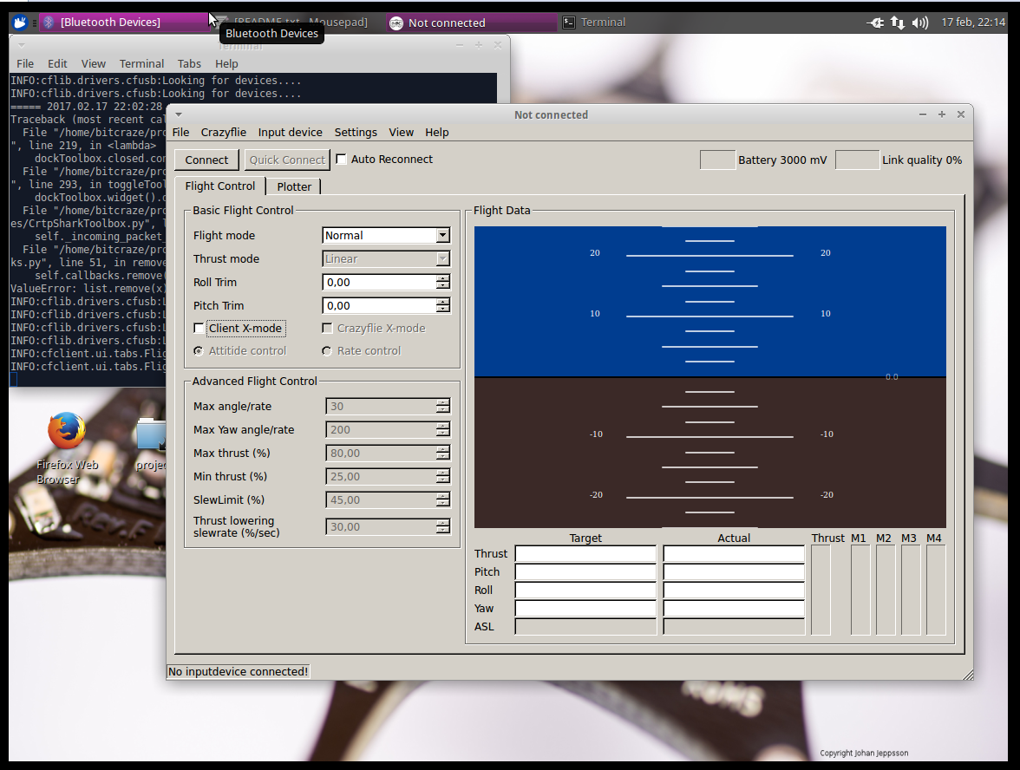

Figure 1: Virtual Machine and included flight software

**Limitations:**

Limitations for this experiment are the inability to map the space where the Quad will be flown. As well as the inability to use GPS to map a route and to test the sensors while flying under GPS control. Another is my lack of experience with the hardware that I am going to be using. This means that I am going to be learning as I go. Despite these limitations, I believe that I will be able to gather sufficient data to confirm or reject the feasibility of flying with only an IMU.

**Sources:**

Bitcraze: <https://www.bitcraze.io/crazyflie-2/>